Below the list of CGP issues, we are facing in many profiles. Please find the snapshots below.

1. **While searching Member ID in Link/Delink getting below popup :**

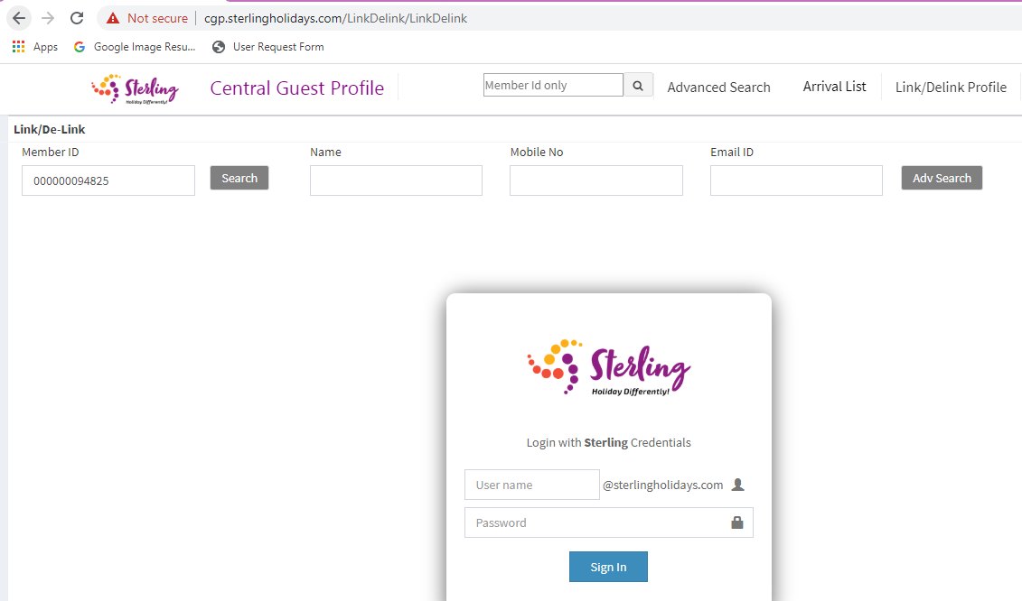

1. **Existing Member Search:**

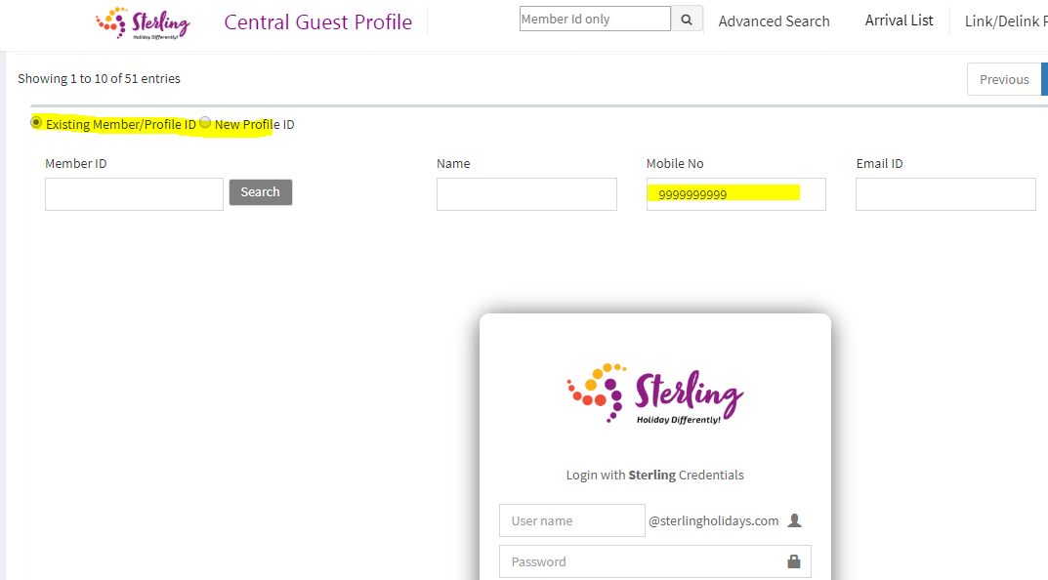

1. **Same profile showing both member id and CGP profile ID:**

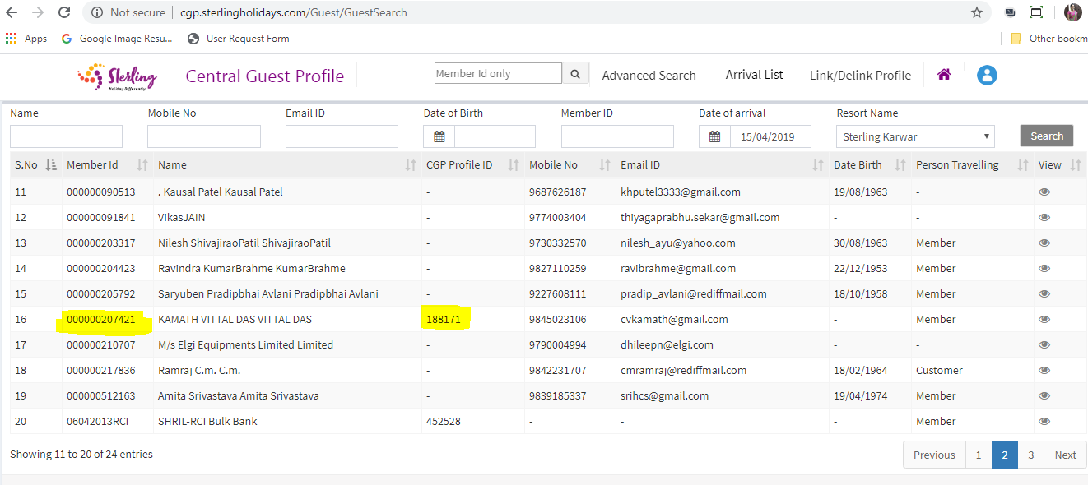

1. **SF Arrival and Departure date missing for some profile:**

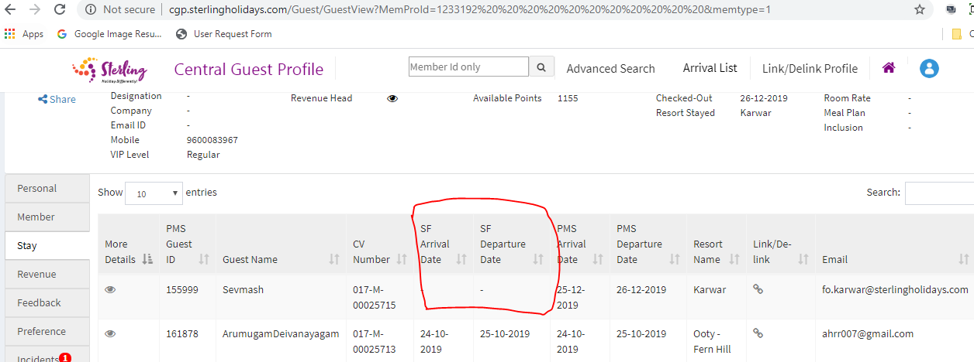

1. **Revenue Value Mismatch(All revenue):**

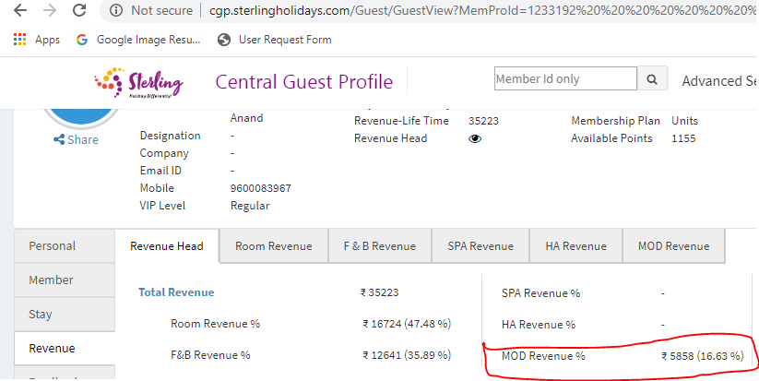

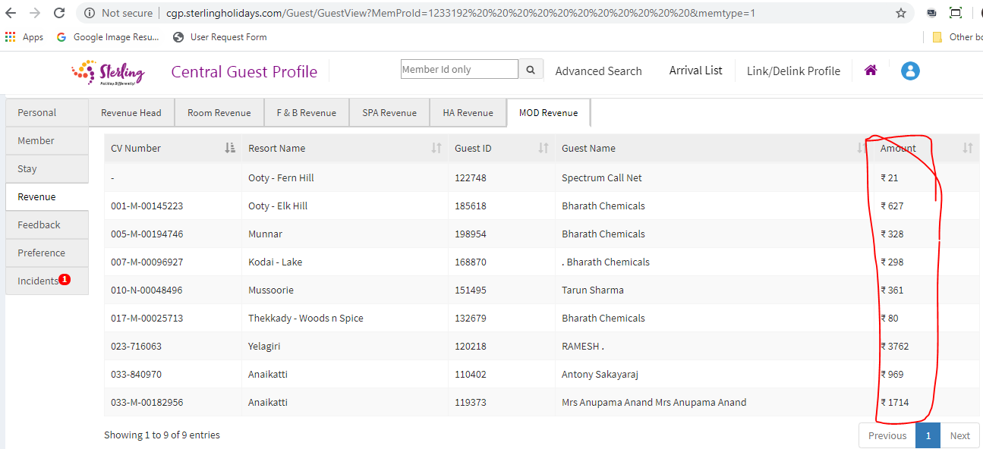

1. **Feedback data incorrect (Overall rating 5 but no data in details(View)):**

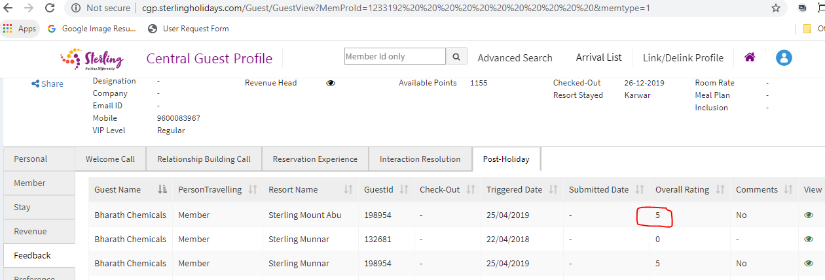

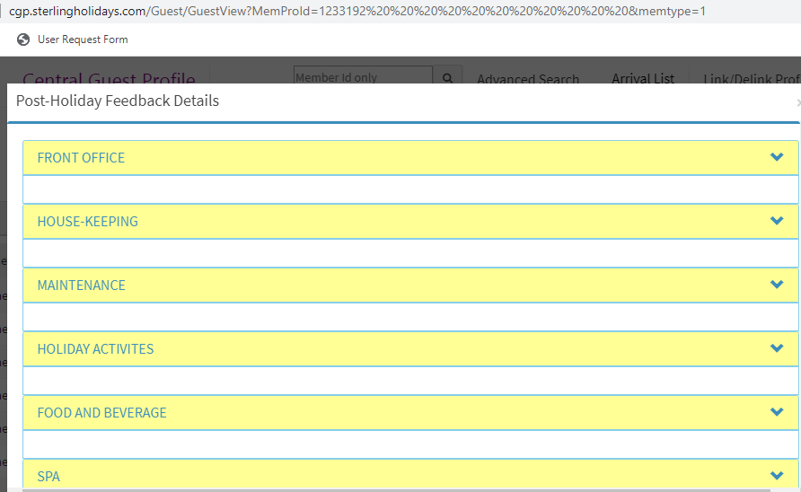

1. **Preference not submitting:**

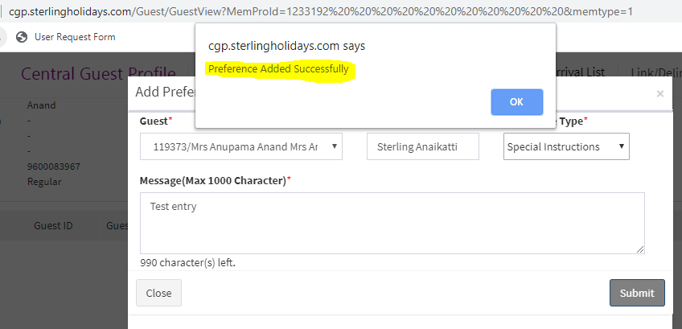

1. **After submitting the preference not data :**

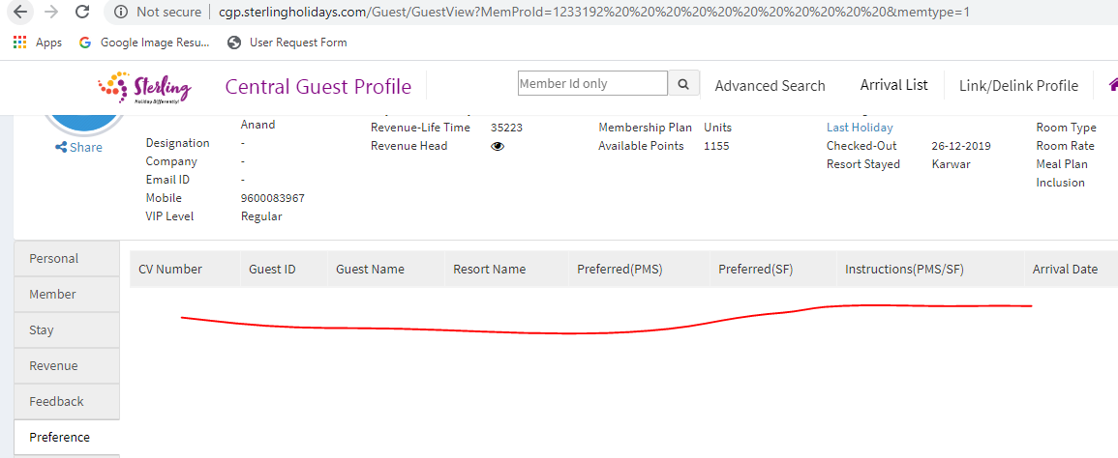

1. **Member’s Guest Most Recent stay data incorrect:**

